Human Resources Management Studies 1 (3) 2021: 186-195  Human Resource Manajemen Studies  http://jkmsdm.ppj.unp.ac.id/index.php/hrms  ISSN: 2798-4400; e-ISSN: 2798-4419  HRMS  Human Resources Management Studies | 
Inclusive Leadership and Innovative Work Behavior:
The Mediating Role of Perceived Organizational Support
Nurhasanah Nasution¹, Syahrizal Syahrizal^{1*}
¹ Department of Management, Universitas Negeri Padang, Padang, Indonesia

ARTICLE INFO |  | ABSTRACT
Received 13 July 2021  Accepted 25 August 2021  Published 30 September 2021 |  | This study aims to determine the effect of inclusive leadership on innovative work behavior with the perception of organizational support as a mediator. This study uses 20 SMEs in Muara Bulian. The population in this study is MSME workers in the Muara Bulian. While the sample used is 90 employees. Data collection is done through distributing questionnaires and data processing is done through smart PLS3. The results of this study indicate that Inclusive leadership has a positive and significant effect on innovative work behavior, Inclusive Leadership has a positive and significant effect on perceptions of organizational support, perceptions of organizational support have a positive and significant effect on innovative work behavior and Inclusive Leadership has a positive and significant effect on innovative work behavior with perceptions organizational support as a mediating variable.
Keywords:
Inclusive Leadership; Perceived Organizational Support; and Innovative Work Behavior


This is an open access article distributed a Creative Commons Attribution-NonCommercial 4.0 International License, which permits unrestricted use, distribution, and reproduction in any medium, provided the original work is properly cited. ©2021 by author.
*Corresponding author: e-mail: Syahrizal@fe.unp.ac.id
INTRODUCTION
Innovation has a very important role for business success, performance, and long-term sustainability and is the lifeblood of the organization (Janssen, 2000). One way that is done in developing the business of an organization is by encouraging employees to carry out and implement innovations (Antonic & Hisrich, 2001). Gray, Matear and Matheson (2002) also say that innovation is very important in achieving competitive advantage in creating something different and collaborative. Thus, innovation is needed in creating innovative employee behavior for successful operations within the company (Scott & Bruce, 1994, Javed, khan, & Quratulain, 2018)
The main purpose of innovation is to meet market demand, therefore innovation is the right strategy in the organization that must be achieved so that the organization or company can compete, so that one of the innovation products owned by the organization can be used as a competitive advantage for the organization (Wahono & Abdullah , 2010). The importance of innovation for continuity and to achieve the overall goals of the company needs to be prepared and support innovation activities for all its employees (Agarwal, 2014).
Innovative behavior not only generates new ideas but also individual or employee behavior that is needed to implement the results of these ideas so as to improve individual and organizational performance. Effective innovative work behavior can be achieved if the organization is able to build good communication with employees and the organization is able to encourage employees to introduce new ideas (Deci & Ryan, 2000). Building communication between workers and organizations means mutually beneficial cooperation and a feeling of belonging (Scholl, 2002).
One of the factors that encourage the creation of innovative behavior is the role of leadership in an organization. The role of the leader as the most influential person in managing tasks and employees has a major influence on the innovative behavior of individuals in the organization (De Jong & Hertog, 2010). The role of the leader is often seen as a success or failure in running an organization. Carmeli, Palmon and Ziv (2010) say that inclusive leadership in improving employees' innovative work behavior is considered more effective than other types of leadership.
The concept of inclusive leadership was first introduced by Nembhard and Edmondson (2006), which states that inclusive leaders will create an environment in which leaders show behavior that respects employee input or opinions so as to create employee confidence that their opinions are truly valued. Inclusive leadership is considered as a determinant of innovation in the workplace, including the presence of inclusiveness, openness, uniqueness and support for innovation in the workplace (Carmeli et al., 2010).
Inclusive leaders have the mindset of trying to understand everyone's point of view, especially their employees. This mindset needs to be applied by an inclusive leader because not all people or employees have the same background, the same beliefs and have different cultures. In general, with the contribution of inclusive leaders to employees, it can make employees feel more dedicated to their leaders so that leaders can encourage innovative behavior of their employees (Javed et al., 2018).
In addition to inclusive leadership, employees' innovative work behavior can also be enhanced through perceived organizational support for employees in the workplace. Perception of organizational support is an employee's perception of the level of employee perception and the level of organizational concern for the level of contribution and employee welfare (Rhoades & Eisenberger, 2002). Every employee has a desire to be noticed and supported by the organization. Organizational support in question is the organization's efforts to reward, pay attention and improve the welfare of its employees for the contributions that have been made by its employees. The amount of attention and support given by the company to employees, either directly or indirectly, can affect employee perceptions of the organization. The more employees feel valued, the employees will provide innovative behavior to advance the company. Organizational support and leadership roles in organizations are needed to bring up innovative behavior of employees (Carmeli et al., 2010).
Inclusive leadership can influence innovative work behavior through organizational support. Social exchange theory reinforces this relationship. Social exchange theory is the view of employees when they have been treated well by the organization, they will tend to repay the organization by being kind and having positive behavior. Employees need to be supported to increase creative ideas in the workplace (Carmeli et al., 2010). The role of the leader in this case, namely increasing the creative ideas of employees is done by encouraging employee motivation to innovate so that employees will feel the leader is responsible for making employee decisions starting from the creation of ideas to realizing the idea. Therefore, organizational support can increase employees' internal motivation in creating creative ideas.
Micro, small and medium enterprises (MSMEs) have a potential role for economic development in Indonesia so that in its implementation it is necessary to optimize and explore the existing potentials for increasing community economic development. MSMEs have a very important role in economic growth, especially in Indonesia and in terms of employment. The existence of the MSME sector is not only considered as a temporary shelter for workers who have not entered the formal sector, but also as the basis for the growth of economic activity. In addition, MSME workers must be able to innovate in their work to face competition in an increasingly competitive business world, this is done because MSMEs are still related to small industries which are one of the small industries that are developing and need to be empowered, especially in terms of innovative work behavior. of the MSME workforce.
This research was conducted on MSME workers in Muara Bulian, Batanghari, Jambi with various types of business lines. Data obtained from the Cooperatives and SMEs Sector of Batanghari Regency that the number of workers in Muara Bulian reaches 3,493 workers. Meanwhile, Muara Bulian is one of the sub-districts that has the largest number of MSME workers compared to other sub-districts.
This research was conducted based on several reasons. First, the role of inclusive leadership that MSME leaders must have in running their business. An inclusive leader will respect all points of view given by his employees, colleagues, clients and business partners. In this case, it means that an inclusive leader will be fair in every diversity that his employees have. However, most leaders are less able to apply inclusive leadership in running a business. Second, there are differences in research results. Afsar and Badir (2016), Wijaya (2018), Qi, et al (2019), Aslan (2019) state that when employees feel that the organization's support is high for employees, employees will show more innovative behavior towards the organization. Employees will see and assess how much support is given by the organization to the performance that has been given. This means that when the organization provides low support for the work of wan, employees cannot bring up innovative work behavior in the workplace. However, in a previous study conducted by Gradiannisa and Salendu (2014) stated that the low level of organizational support such as supervisor support provided by the organization to employees as a function of innovative work behavior. This means that despite low organizational support, employees can still develop innovative behavior in the workplace.
LITERATURE REVIEW

Innovative Work Behavior
Janssen (2000), explains that innovative behavior is the creation, introduction, and implementation of new ideas or ideas in work, organizational groups with the aim of improving the role performance of individuals, groups and organizations. Messmann (2020) states that innovative work behavior is all physical work activities and knowledge of work processes carried out by employees in several forms of their work, both individually and in groups to achieve an organizational goal.
Based on some of the definitions above, it can be concluded that innovative work behavior is a process of idea discovery, idea recognition, and its application to employee innovations that are beneficial to an organization. In this study, to measure the level of innovative work behavior in MSME workers in Muara Bulian, the indicators used according to Janssen (2000): Creating ideas (Idea generation), Sharing ideas (Idea promotion), Realization of ideas (Idea Realization).

Inclusive Leadership
Inclusive leadership is defined as a leader's actions and words that show his contribution to each of his employees (Nembhard & Edmondson, 2006). Carmeli et al (2010) suggested that inclusive leaders are leaders who demonstrate openness, availability, and accessibility in interacting with their employees. An inclusive leader is fully responsible for contributing to the work members to get good results and will be respected by every employee (Javed et al., 2018).
Based on some of the definitions above, it can be concluded that inclusive leadership is openness, willingness and respect given by leaders to each of their employees by respecting the various perspectives of employees and appreciating the different characteristics of their employees at work. Inclusive leadership is a leader who has responsibility for the contribution of his employees and values ​​every participation by encouraging organizational growth and working together to achieve the same goal.
The indicator used by the author to measure the inclusive leadership variable in this study refers to the opinion of Carmeli et al (2010), namely Openness, Availability, Accessibility.

Perceived Organizational Support
Organizational support is defined as the extent to which the organization provides support to employees so that it affects employee perceptions and the extent to which the organization cares when it is needed by employees (Rhoades & Eisenberger, 2002). If employees perceive that the organizational support they receive is high, then employees will integrate membership as a member of the organization into their self-identity and then develop a more positive perceived relationship with the organization. Labrague, Petitte and Tsaras (2018) define perceived organizational support as an effort made by the organization to appreciate, reward and care for employees.
Based on the explanations and opinions of the experts above, it can be said that the perception of organizational support is the level where employees feel confident that the organization values ​​their contributions and cares about their welfare which can result in a reciprocal relationship between the two.
Rhoades and Eisenberger (2002) explain that there are three indicators in measuring the perception of organizational support, namely Fairness, Supervisor support and Organizational rewards and job conditions.

Inclusive Leadership and Innovative Work Behavior
Based on research conducted by Aslan (2019), inclusive leadership has a significant positive effect on innovative work behavior, this means that if the leader respects all employees by involving all employees in the decision-making process by creating an open environment and respecting the role of employees fairly, employees will be more open. leaders to show their innovative behavior, in the form of introducing new ideas. Sharifirad and Ataei (2012) suggest that inclusive leaders must involve employees in decision making and can ensure the accessibility of leaders in helping employees, this can provide opportunities for employees to be active and have innovative thinking at work.

H1: Inclusive Leadership has a positive and significant effect on innovative work behavior

Inclusive Leadership and Perceived Organizational Support
Based on research conducted by Qi et al (2019), it is stated that inclusive leadership has a positive effect on perceptions of organizational support. This means that, supervisors in leadership roles play a role in providing organizational resources, inclusive leaders provide enormous benefits to their employees. The fair and open behavior of an inclusive leader can help employees understand that their contributions are valued by the organization and that employee well-being is cared for by the organization. Xiang, Chen and Zhao (2017) mention that leaders who play inclusive leadership can provide support to employees and look after employees at work, so employees will feel organizational support from their leaders.

H2: Inclusive Leadership has a positive and significant effect on perceptions of organizational support

Perception of Organizational Support and Innovative Work Behavior
Wijaya (2018) states that the perception of organizational support has a positive effect on innovative work behavior, meaning that if the perception of organizational support in an organization is high, the innovative work behavior will also be high, otherwise if the perception of organizational support is low, the innovative behavior of employees will also be low. Eisenberger (2002) says that organizational support for employees in the form of promotions, salaries and work safety can improve employee innovative work behavior. Research conducted by Dogru (2018) explains that when employees are supported by the organization, employees will respond with positive behavior towards the organization.

H3: Perception of organizational support has a positive and significant effect on innovative work behavior

The Mediating Effect of Perception of Organizational Support
Based on research conducted by Qi et al (2019), it is stated that the perception of organizational support as a mediating variable is able to mediate the relationship between inclusive leadership variables and innovative work behavior. This means that, if inclusive leadership is high, then the innovative work behavior of employees will also be high and the perception of high organizational support will also affect innovative work behavior. Aslan (2019) also said that the role of inclusive leadership will influence the innovative behavior of employees in the organization. This can also be influenced by the perception of high organizational support and employees will also try to do things that are beneficial for the organization.

H4: Perceived organizational support mediates the relationship between inclusive leadership variables on innovative work behavior.
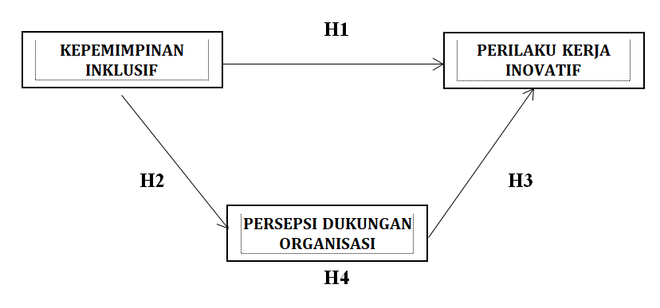
Figure 1: Research Model

METHOD

The research design to be carried out is classified as a causative descriptive study. This research was conducted to see the extent of the influence of inclusive leadership on innovative work behavior with the perception of organizational support as a mediating variable on the msme workforce in muara bulian district. The population in this study is msme workers in the Muara Bulian. Meanwhile, for sampling, the writer uses purposive sampling technique, which is the sampling technique used by the researcher if the researcher has considerations or based on certain criteria. The number of samples that became respondents in the study amounted to 90 employees. The source of data used in this study is primary data where research data is obtained directly from research respondents. Collecting data in this study using a questionnaire with a likert scale, then analyzed using the pls (partial least square) analysis technique.
RESULT AND DISCUSSION
Descriptive Analysis Results

Table 1. Variable Descriptive Analysis Results
No | Variable | Average Score (Mean) | Respondent’s level of achievement | Category
1 | Inclusive Leadership | 4,28 | 85,55% | High
2 | Innovative Work Behavior | 4,39 | 87,70% | High
3 | Perceived Organizational Support | 4,40 | 88,08% | High

Based on the table 1 the results of the calculation of the frequency distribution to measure innovative work behavior used 3 indicators with 13 statement items showing an accumulated average score of 4.28 and a Respondents level of achievement of 85.55% where this value was categorized as high. Thus, it can be concluded that the innovative work behavior of MSME workers in Muara Bulian t is said to be high and can still be improved.
Based on the table 1 the results of the calculation of the frequency distribution to measure inclusive leadership used 3 indicators with 9 statement items showing an accumulated average score of 4.39 and a Respondents level of achievement of 87.70% where this value is categorized as high. Thus, it can be concluded that the inclusive leadership of the MSME workforce in Muara Bulian is said to be high and can still be improved.
Based on the table 1 the results of the calculation of the frequency distribution to measure the perception of organizational support used 3 indicators with 14 statement items showing an accumulated average score of 4.40 and a Respondents level of achievement of 88.08% where this value is categorized as high. Thus, it can be concluded that the perception of organizational support for MSME workers in Muara Bulian is said to be high and can still be improved.

Inferential Analysis Results
This research uses data analysis method using SmartPLS 3.0 software. PLS (Partial Least Square) which is a variant-based structural equation analysis (SEM) that can simultaneously test the measurement model as well as test the structural model.

Measurement Model
The measurement model (inner model) is used to assess the validity and reliability of the model.

Convergent Validity
Based on the results of the validity test carried out using SmartPLS 3.0, through the PLS calculation by looking at the outer loading value, it can be seen that the variables of innovative work behavior, inclusive leadership and perceived organizational support have a correlation value that is greater than the r-table which is more 0.5. So it can be concluded that the statement indicators used have good validity. The AVE value for the innovative work behavior variable is 0.710, inclusive leadership is 0.654 and for the perceived organizational support variable is 0.559. From the value of each AVE on each indicator, the indicators for each construct are valid with other items in one measurement.
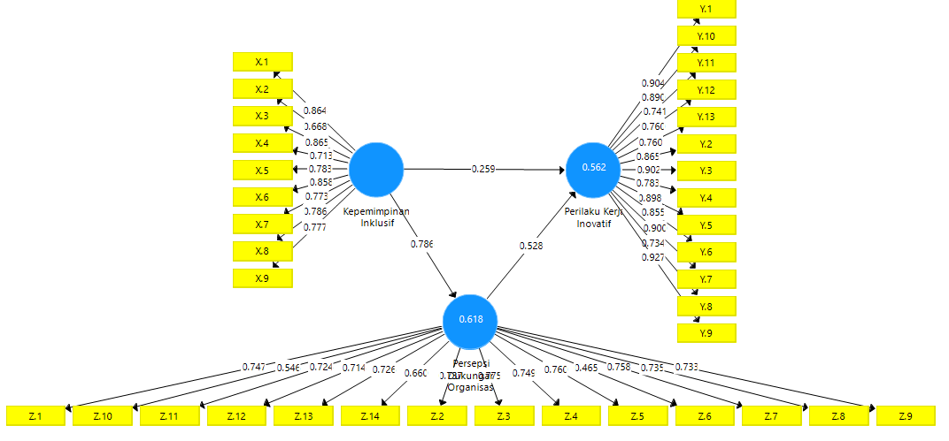
Figure 2: Outer Model of Initial Research

Discriminant Validity and Composite reliability
Discriminant validity is to compare the Square Root of Average (AVE) for each construct with the correlation between the construct and other constructs in the model. The construct is said to be valid if it has an AVE value > 0.5. The following are the results of the Discriminant validity test:

Table 2: Discriminant validity test results – AVE value and Reliability Test Results
 | AVE | Composite Reliability
Inclusive Leadership | 0,654 | 0,938
Innovative Work Behavior | 0,710 | 0,969
Perceived Organizational Support | 0,559 | 0,933

Based on the results of the above values, it can be concluded that from the results of each variable, the AVE value is above 0.5. Then all indicators have met the requirements of Discriminant validity. While the composite reliability value for all constructs is above 0.7 which indicates that all constructs in the estimated model meet the criteria or are reliable.

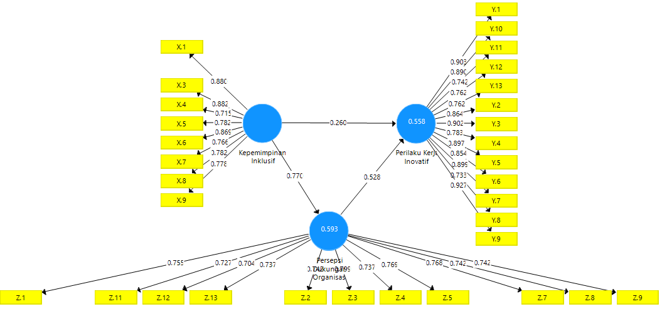
Figure 3: Outer Model of the Final Research

R-Square
This analysis was conducted to see the effect of exogenous variables on endogenous variables. The following is the r-square value in table 3:
Table 3: Results of R-square Analisis analysis
 | R-square
Innovative Work Behavior | 0,558
Inclusive Leadership
Perceived Organizational Support | 0,593

Table 3 shows the R-square value of the innovative work behavior variable obtained by 0.558, this result shows that 55.8% of the innovative work behavior variable can be influenced by the inclusive leadership variable. Meanwhile, the perceived organizational support variable is 0.593, this result shows that 59.3% of the perceived organizational support and inclusive leadership variable can be influenced by the innovative work behavior variable.

Hypothesis test
Hypothesis testing was carried out using the bootstrapping method on SmartPLS 3.0 software so that the relationship between the influence of exogenous variables on endogenous variables was obtained as follows. The research hypothesis can be accepted if the t-statistic > 1.96. The following are the results of the direct influence hypothesis test:

Table 4: Hypothesis Test – Direct effect and indirect effect
 | Original Sample | Sample average | Standard deviation | T Statistik
Direct Effect
Inclusive Leadership > Innovative Work Behavior | 0,260 | 0,247 | 0,124 | 2,094
Inclusive Leadership > Perceived Organizational Support | 0,770 | 0,775 | 0,058 | 13,295
Perceived Organizational Support > Innovative Work Behavior | 0,528 | 0,539 | 0,107 | 4,923
Indirect Effect
Inclusive Leadership > Innovative Work Behavior > Perceived Organizational Support | 0,406 | 0,420 | 0,102 | 3,987
Source: Results from processing SmartPLS3, 2021

- The variable of inclusive leadership has a positive and significant effect on innovative work behavior, with a T-Statistic of 2,904 > 1,96, and a path coefficient of 0,260.
- The variable of inclusive leadership has a positive and significant effect on perceptions of organizational support, with a T-Statistic of 13, 295 > 1,96, and a path coefficient of 0,770.
- The variable perception of organizational support has a positive and significant effect on innovative work behavior, with a T-Statistic of 4,923 > 1,96, and a path coefficient of 0,528.
- Based on the results of the calculation of the indirect variable coefficient, the t-statistic value of the indirect influence of inclusive leadership on employee innovative work behavior through the perception of organizational support is 3.987 > 1.96, and the path coefficient is 0.406. It can be concluded that inclusive leadership has a significant effect on employees' innovative work behavior through perceptions of organizational support.

CONCLUSSION
Based on the discussion that has been described, it can be concluded, 1) Inclusive leadership has a direct and significant and positive effect on innovative work behavior in the workforce of Micro, Small and Medium Enterprises (MSMEs) in Muara Bulian. This means that employees will have a high level of innovative work behavior if the leader is able to apply optimal inclusive leadership to his employees. 2) Inclusive leadership has a direct and significant and positive effect on the perception of organizational support for the workforce of Micro, Small and Medium Enterprises (MSMEs) in Muara Bulian. This means that MSME workers in Muara Bulian feel that supervisors as leaders apply inclusive leadership to be able to influence the perception of organizational support that employees feel at work. 3) Perceptions of organizational support have a direct and significant and positive effect on organizational innovative work behavior on the workforce of Micro, Small and Medium Enterprises (MSMEs) in Muara Bulian. This means that the higher the perceived level of organizational support felt by employees towards their organization, the higher the innovative work behavior of employees will be. 4) Inclusive leadership has an indirect and significant and positive effect on innovative work behavior through perceptions of organizational support for the workforce of micro, small and medium enterprises (MSMEs) in Muara Bulian.

LIMITATIONS
This study has limitations, among others, this study only used a sample of 90 employees of Micro, Small and Medium Enterprises (MSMEs) in Muara Bulian. The author also limits the problem that the writer examines to the factors that according to the author have an effect on innovative work behavior, inclusive leadership, perceived organizational support.
REFERENCES
Afsar, B., & Badir, Y. (2017). Workplace spirituality, perceived organizational support and innovative work behavior: The mediating effects of person-organization fit. Journal of Workplace Learning, 29(2), 95–109.
Agarwal, U.A (2014). Examining the impact of social exchange relantioships on innovative work behaviour: Role of work engangement. Team Performance Management, 20(3/4), 102-120. https://doi.org/10.1108/TPM-01-2013-0004
Antoncic, B., & Hisrich, R. D. (2001). Intrapreneurship: Construct refinement and cross-cultural validation. Journal of Business Venturing, 16(5), 495–527.
Aslan, H. (2019). Mediating Role of Perceived Organizational Support in Inclusive Leadership’S Effect on Innovative Work Behavior. Business & Management Studies: An International Journal, 7(5), 2945–2963.
Carmeli, A., Reiter-Palmon, R., & Ziv, E. (2010). Inclusive leadership and employee involvement in creative tasks in the workplace: The mediating role of psychological safety. Creativity Research Journal, 22(3), 250–260.
De Jong, J., & Den Hartog, D. (2010). Measuring innovative work behaviour. Creativity and Innovation Management, 19(1), 23–36.
Deci, E.L., & Ryan, R.M. (2000). Self determination theory and the facilitation of instrinsic motivation, social development, and well-being. American Psycological Asociation, 55(1), 68-78
Doğru, Ç. (2018). The Relationship between Perceived Support and Innovative Behavior: Analyzing the Mediating Role of Work Engagement. Journal of Business Research - Turk, 10(2), 384–402.
Gradiannisa, Y. & Salendu, A. (2014). Hubungan antara persepsi dukungan organisasi dengan perilaku inovatif di tempat kerja pada karyawan (Studi pada PT. X). Jurnal Psikologi, 1(3), 1–20.
Gray, B. J., Matear, S., & Matheson, P. K. (2002). Improving service firm performance. Journal of Services Marketing, 16(3), 186–200.
Javed, B., Abdullah, I., Zaffar, M. A., Haque, A. U., & Rubab, U. (2018). Inclusive leadership and innovative work behavior: The role of psychological empowerment. Journal of Management and Organization, 25(4), 554–571.
Javed, B., Khan, A. K., & Quratulain, S. (2018). Inclusive Leadership and Innovative Work Behavior: Examination of LMX Perspective in Small Capitalized Textile Firms. Journal of Psychology: Interdisciplinary and Applied, 152(8), 594–612.
Labrague, L. J., McEnroe Petitte, D. M., Leocadio, M. C., Van Bogaert, P., & Tsaras, K. (2018). Perceptions of organizational support and its impact on nurses’ job outcomes. Nursing Forum, 53(3), 339–347.
Messmann, G., & Mulder, R. H. (2020). A short measure of innovative work behaviour as a dynamic, context-bound construct. International Journal of Manpower, 41(8), 1251–1267.
Nembhard, I.M & Edmondson, A.C.(2006). Making It Safe: The Effects Of Leader Inclusiveness And Professional Status On Psychological Safety And Improvement Efforts In Health Care Teams. Journal of Organizational Behaviour. 27, 941-966
Onne Janssen. (2000). Job demands, perceptions of effort-reward fairness nd innovative work behavior. Journal of Occupational and Organizational Psychology, 287–302.
Qi, L., Liu, B., Wei, X., & Hu, Y. (2019). Impact of inclusive leadership on employee innovative behavior: Perceived organizational support as a mediator. PLoS ONE, 14(2), 1–14.
Rhoades, L., & Eisenberger, R. (2002). Perceived organizational support: A review of the literature. Journal of Applied Psychology, 87(4), 698–714. https://doi.org/10.1037/0021-9010.87.4.698
Scott, S. G., Bruce, R. A., Scott, S. G., & Bruce, R. A. (1994). Determinants of Innovative Behavior: A Path Model Of Individual Innovation In The Workplace. Academy of Management Journal. 32(03), 580-607
Sharifirad, M.S., & Ataei, V. (2012). Organizational culture and innovation culture: eploring the relationshipd between constructs. Leadership & Organization Developmen Journal, 33 (5), 494-517
Wijaya, O.Y.A. (2018). Effect of Leader Member Exchange and Perceived Organizational Support on Innovative Work Behavior of Star Rated Hotel Employees. Journal of Applied Management (JAM). 16(4), 574-585
Xiaotao, Z., Yang, X., Diaz, I., & Yu, M. (2018). Is too much inclusive leadership a good thing? An examination of curvilinear relationship between inclusive leadership and employees’ task performance. International Journal of Manpower, 39(7), 882–895.
Xiang, H., Chen, Y., & Zhao, F. (2017). Inclusive Leadership, Psychological Capital, and Employee Innovation Performance: The Moderating Role of Leader-Member Exchange. DEStech Transactions on Social Science, Education and Human Science, 239-243.

